Latin America Political Map
Directions: Use the world atlas posted on my website to label the following countries in Latin America: Brazil, Chile, Colombia, Cuba, Mexico, and Panama. Color!
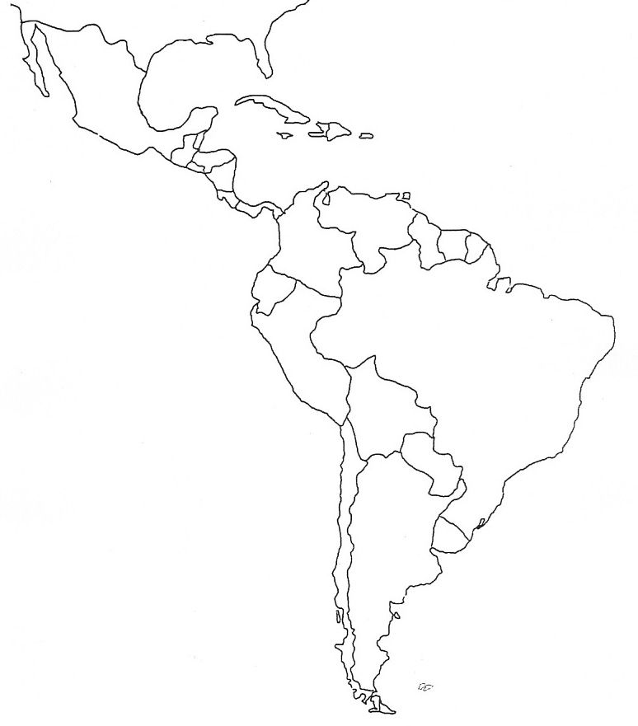
Latin America Physical Map
Directions: Use the world atlas posted on my website to label the following physical features in Latin America: Amazon Rainforest, Amazon River, Caribbean Sea, Gulf of Mexico, Atlantic Ocean, Pacific Ocean, Panama Canal, Andes Mountains, Sierra Madre Mountains, Atacama Desert. Color!
