Name:_____________________________ Period: ____________ Date: __________________

Directions: To complete the following you may use online resources, or you may also use the maps from the textbook found on pages 556 and 435.

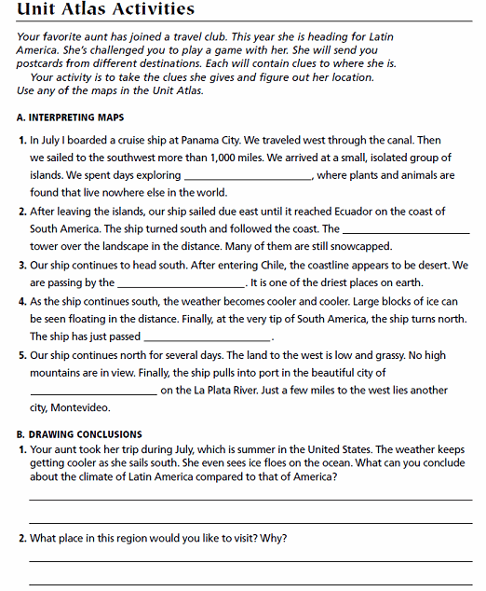
east

