Triangular trade Notes
- Before Columbus landed in the New World there was somewhere between 50 to 100 million indigenous people in the Americas.
  - Due to European guns, steel, horses, and especially DISEASES their population dropped to around 2.1-7 million people.
- European countries sent explorers to look for GOLD and other valuable resources that would make them rich.
  - Sugar and tobacco became two major cash crops grown in the region and required a large supply of workers.
  - Since most Native Americans that were used for labor died due to new diseases, Europeans turned to Africa. ​
    - Africans were from the Old World so they had already been exposed to European diseases, Africans knew how to farm, and Africans were unfamiliar with the land.
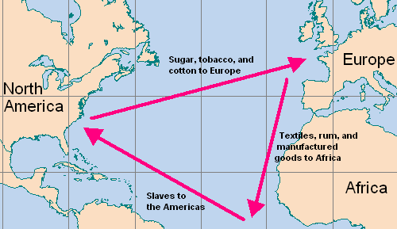
- Triangular trade was the three-stage pattern of trade that carried goods and enslaved people between Europe, Africa, and the Americas.
- Most Enslaved Africans were shipped to the Caribbean and Brazil.

